Json Research

**JSON** (JavaScript Object Notation) is a lightweight data-interchange format. It is easy for humans to read and write. It is easy for machines to parse and generate. It is based on a subset of the [JavaScript Programming Language](http://javascript.crockford.com/), [Standard ECMA-262 3rd Edition - December 1999](http://www.ecma-international.org/publications/files/ecma-st/ECMA-262.pdf). JSON is a text format that is completely language independent but uses conventions that are familiar to programmers of the C-family of languages, including C, C++, C#, Java, JavaScript, Perl, Python, and many others. These properties make JSON an ideal data-interchange language.

JSON is built on two structures:

* A collection of name/value pairs. In various languages, this is realized as an *object*, record, struct, dictionary, hash table, keyed list, or associative array.
* An ordered list of values. In most languages, this is realized as an *array*, vector, list, or sequence.

These are universal data structures. Virtually all modern programming languages support them in one form or another. It makes sense that a data format that is interchangeable with programming languages also be based on these structures.

In JSON, they take on these forms:

An *object* is an unordered set of name/value pairs. An object begins with **{** (left brace) and ends with **}** (right brace). Each name is followed by **:** (colon) and the name/value pairs are separated by **,** (comma).

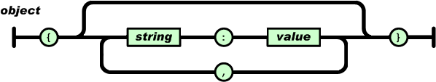

An *array* is an ordered collection of values. An array begins with **[** (left bracket) and ends with**]** (right bracket). Values are separated by **,** (comma).

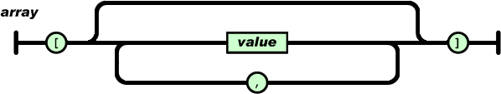

A *value* can be a *string* in double quotes, or a *number*, or **true** or **false** or **null**, or an *object*or an *array*. These structures can be nested.

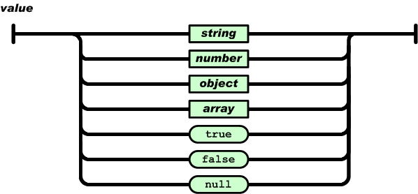

A *string* is a sequence of zero or more Unicode characters, wrapped in double quotes, using backslash escapes. A character is represented as a single character string. A string is very much like a C or Java string.

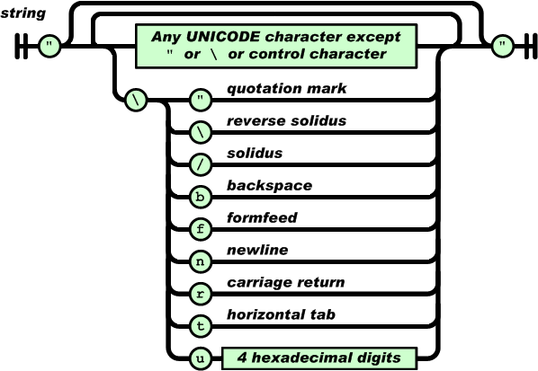

A *number* is very much like a C or Java number, except that the octal and hexadecimal formats are not used.

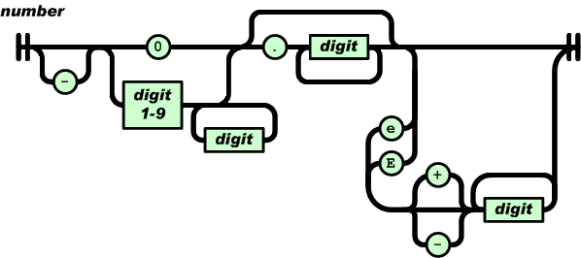

Whitespace can be inserted between any pair of tokens. Excepting a few encoding details, that completely describes the language.